**Assignment -2**

|  |  |
| --- | --- |
| Assignment Date | 27 September 2022 |
| Student Name | Ms.KOTA SRILAKSHMI |
| Student Roll Number | 111519106074 |
| Maximum Marks | 2 Marks |

**QUESTION 1:**

**BUILD A PYTHON CODE , ASSUM EYOU GET A TEMPERATURE AND HUMIDITY VALUES GENERATED WITH RANDOM FUNCTION TO A VARIABLE AND WRITE A CONDITION TO CONTINUOUSLY DETECT ALARM IN CASE OF HIGH TEMPERATURE.**

**Program:**

import random

import winsound

temperature= random.randrange(0,100)

print(temperature)

if(temperature>60):

print("HIGH TEMPERATURE")

#print('\a')

winsound.Beep(4460, 10000)

else:

print("NORMAL TEMPERATURE")

difference=random.randint(3,8)

dewpoint=temperature-difference

print("dewpoint=",end=" ")

print(dewpoint)

#Relative Humidity

rh=100*(2.718281828*(17.625*dewpoint/(243.04+dewpoint)))/(2.718281828*(17.625*temperature/(243.04+temperature)))

print("Relative Humidity=",end=" ")

print(rh)

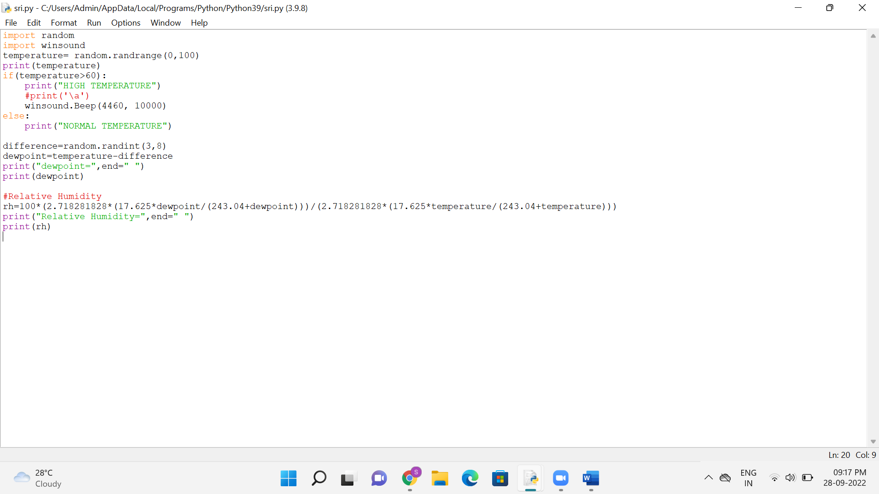

**Output:**

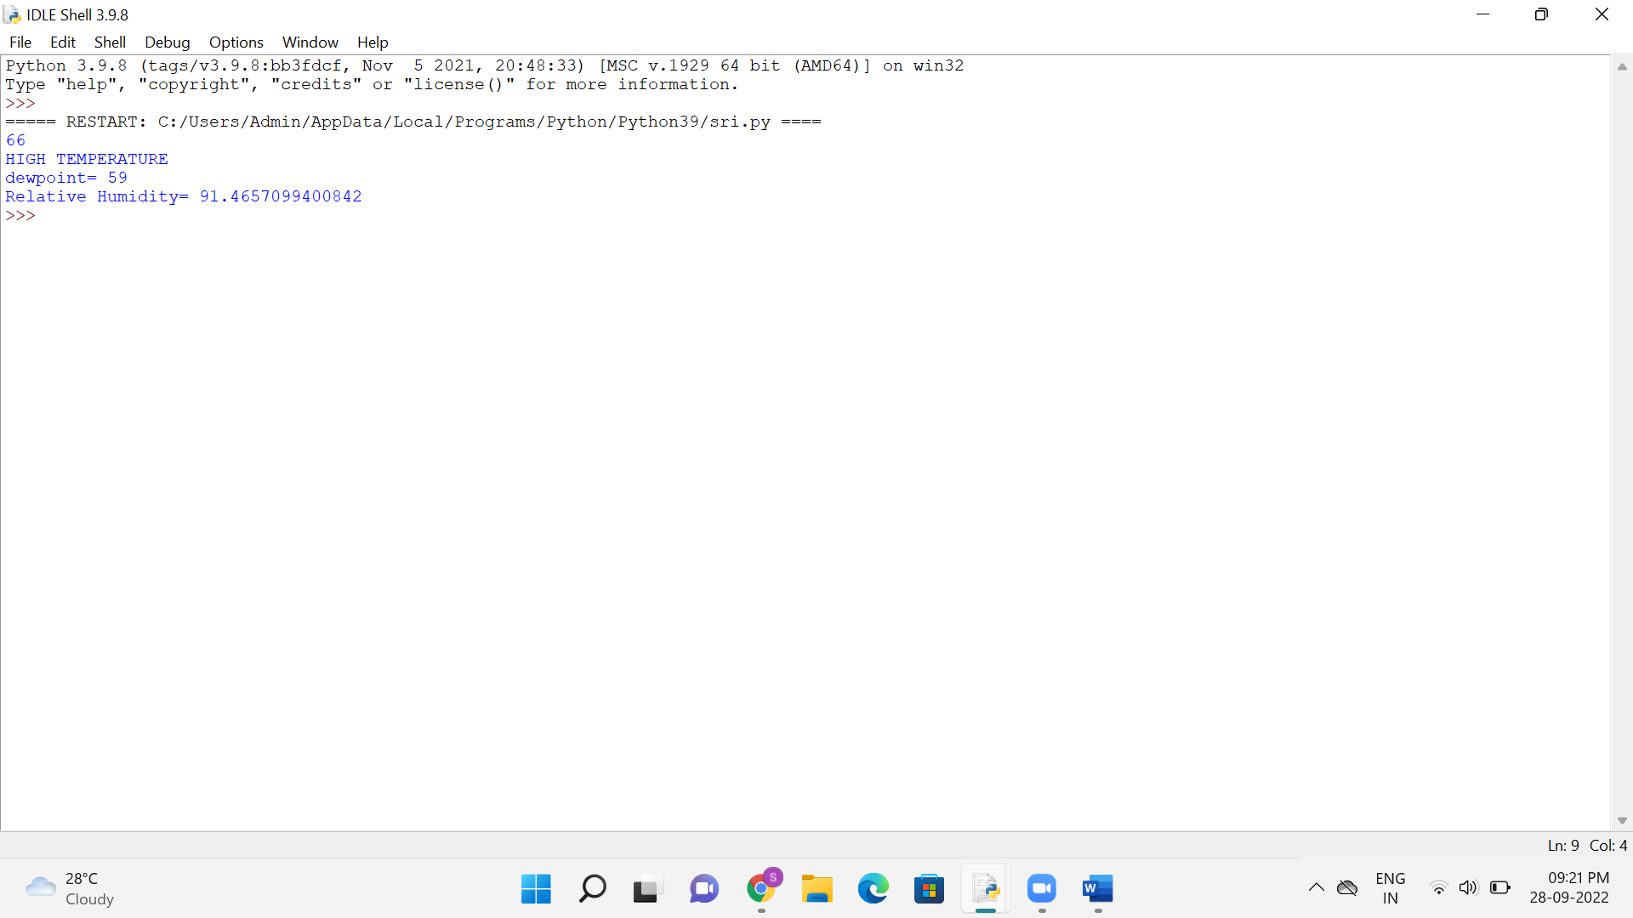

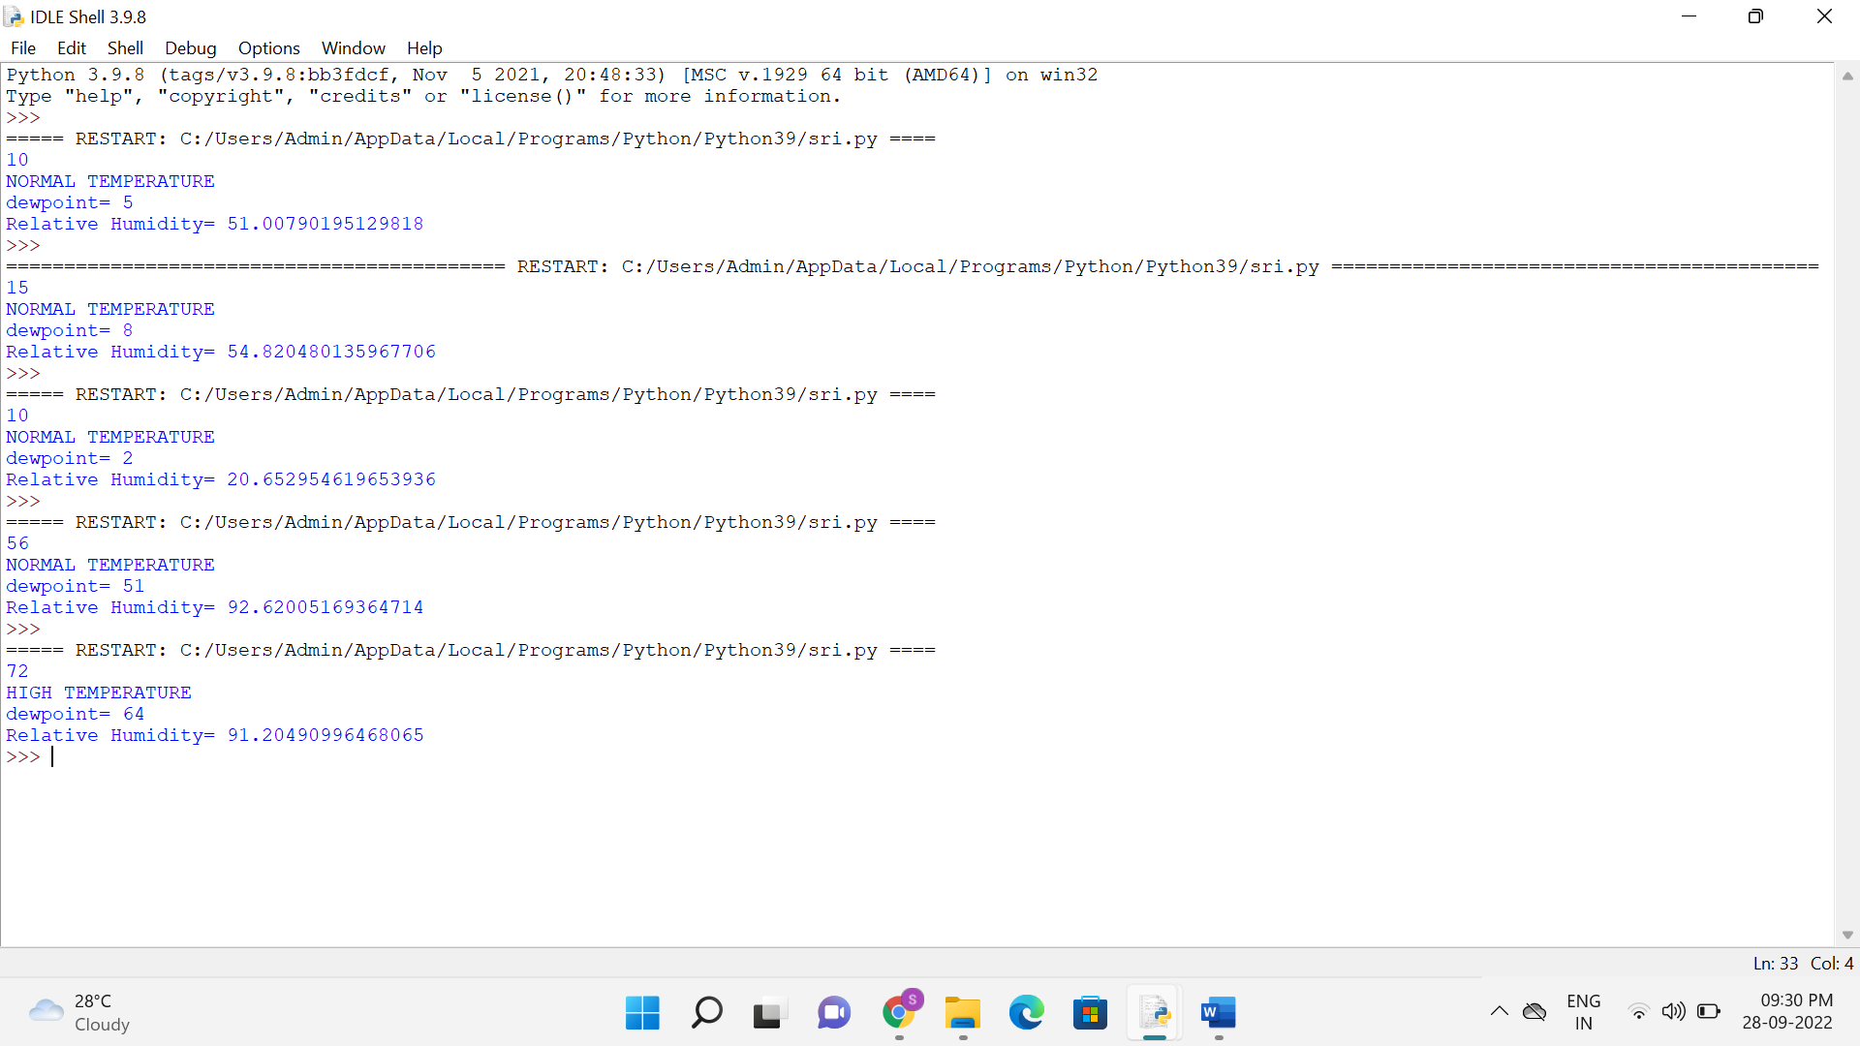

**Drive Link:**

**https://drive.google.com/file/d/10WCMociekytmcwaZg-poDnsHbiihF4qc/view?usp=sharing**